Name: Pochampally Shyamala

Registration No:
Module Name: Module-11-GitHub AI _Q2
Interduction:
problem Statement
The goal of this project is to develop a machine learning system that predicts the price of a used car based on features like:
- Year of manufacture
- Mileage
- Fuel type
The system also provides an interactive dashboard using Streamlit.
Aim:
2. Car Price Prediction Dashboard
Problem:
Develop an interface to predict used car prices using features like year, fuel type, and mileage.
Task:
- Load and clean car dataset.
- Perform regression modeling.
- Visualize feature importance.
- Create user input interface.
- Display predicted price with charts.

Objective
- Build a regression model for price prediction
- Clean and preprocess car dataset
- Visualize feature importance
- Create user-friendly interface
- Display predicted price with charts
Requirements
- Using Desktop,
- keyboard,
- Google Colab,
- Mouse
- Gather data do you understand character ,string,count ,dictionary
- Python installed

4. Tools & Technologies
• Python
• Pandas
• NumPy
• Scikit-learn
• Matplotlib / Seaborn
• Streamlit , Git & GitHub



Steps:
Step1:How to open Jupyter note nook:
  - First step go start button search google colab Notebook document open.
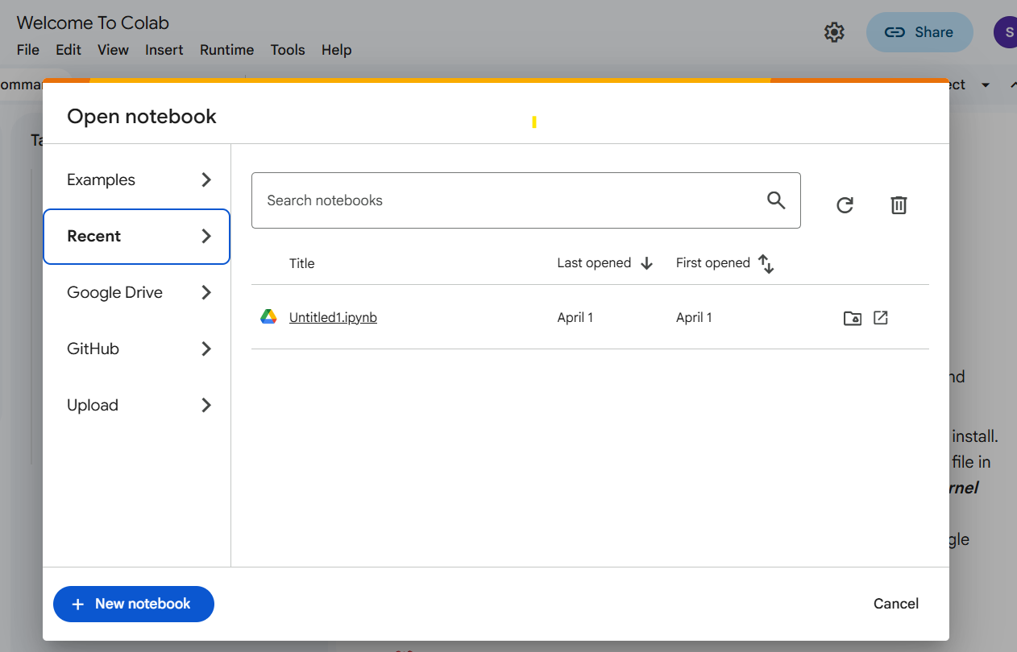

Step2: Howto create colab file
colab server downloading all files taking some time Jupiter notebook open.
Create file name set-D exam.ipynb .
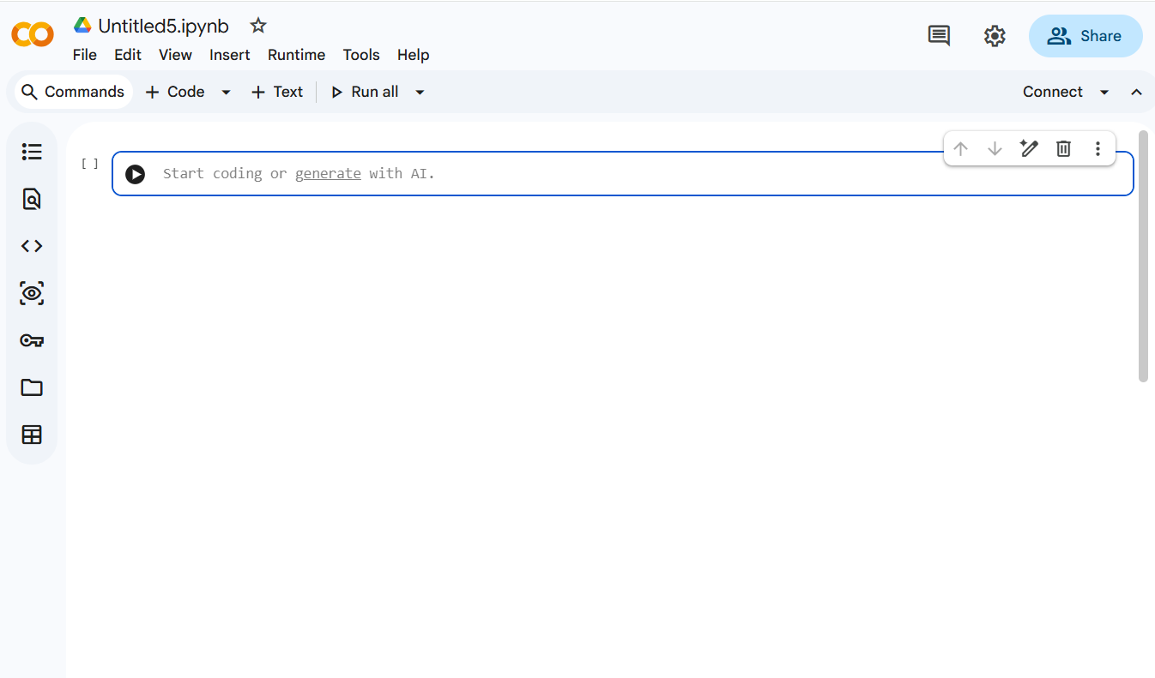

Steps and Code:
Project Structure
Car-Price-Prediction/
│
├── car_data.csv
├── car_dashboard.py
├── requirements.txt
└── README.md
Step 1: Create GitHub Repository
- Login to GitHub.
- Click New Repository.
- Repository Name: Student-Performance-Prediction
- Select Public.
- Click Create Repository.
Clone repository:
git clone https://github.com/ShyamalaGurugari /Student-Performance-Prediction.git
cd Student-Performance-Prediction
Dataset Description
Feature | Description
Year | Manufacturing year
Mileage | Distance driven
FuelType | Petrol / Diesel
Price | Target variable

Step 2: Import Libraries
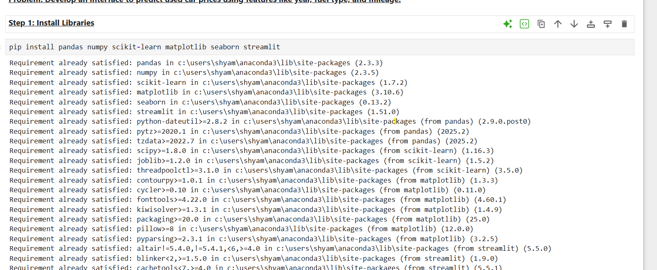
Step 3: Load and Clean Dataset
• Import car dataset (car_data.csv)
• Check for missing values and data structure
• Remove null values
• Handle categorical variables (Fuel Type)

Step 4: Convert Fuel Type to Numeric
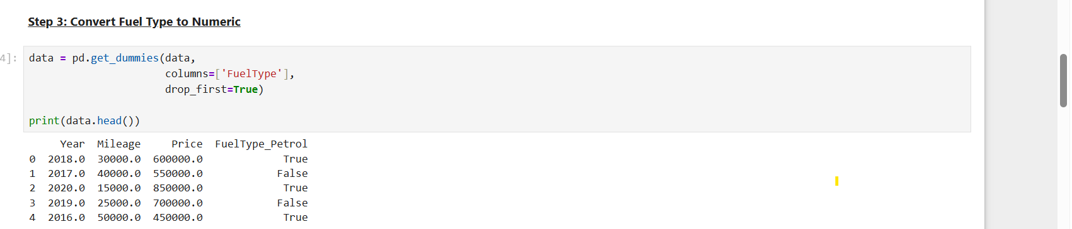
Step 5: Define Features & Target
• X = input features
• y = car price
Step 5: Train Regression Model
• Train data → model learning
• Test data → model evaluation
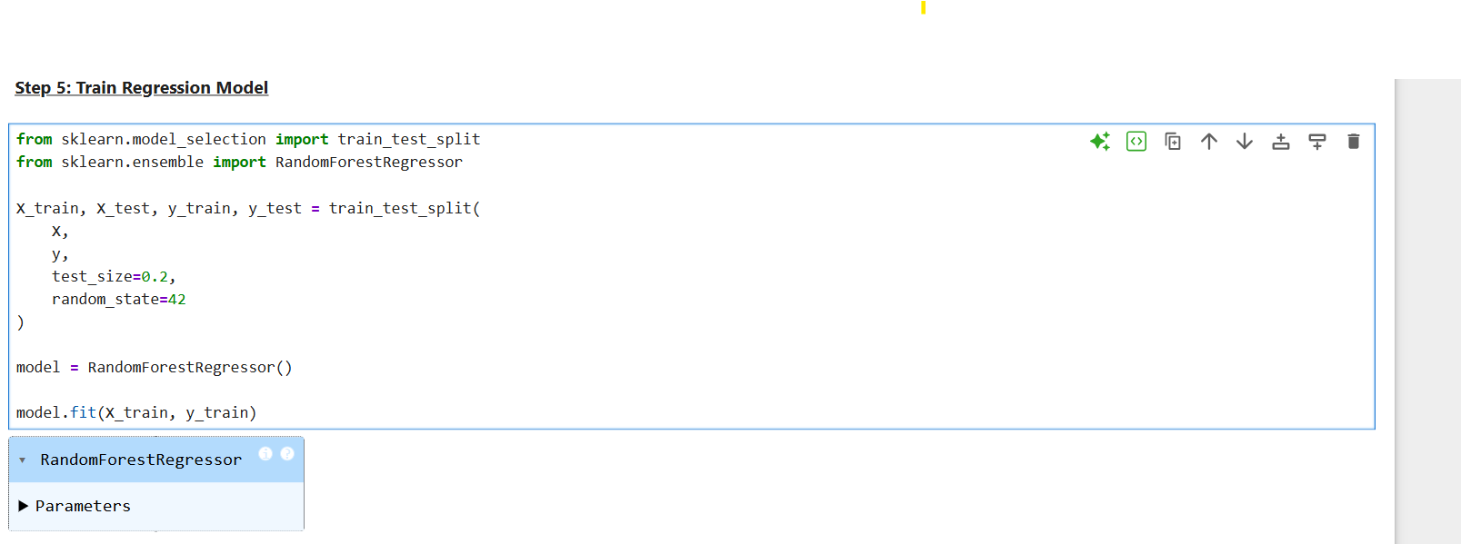

Step 6: Feature Importance Visualization
Shows which feature affects price most
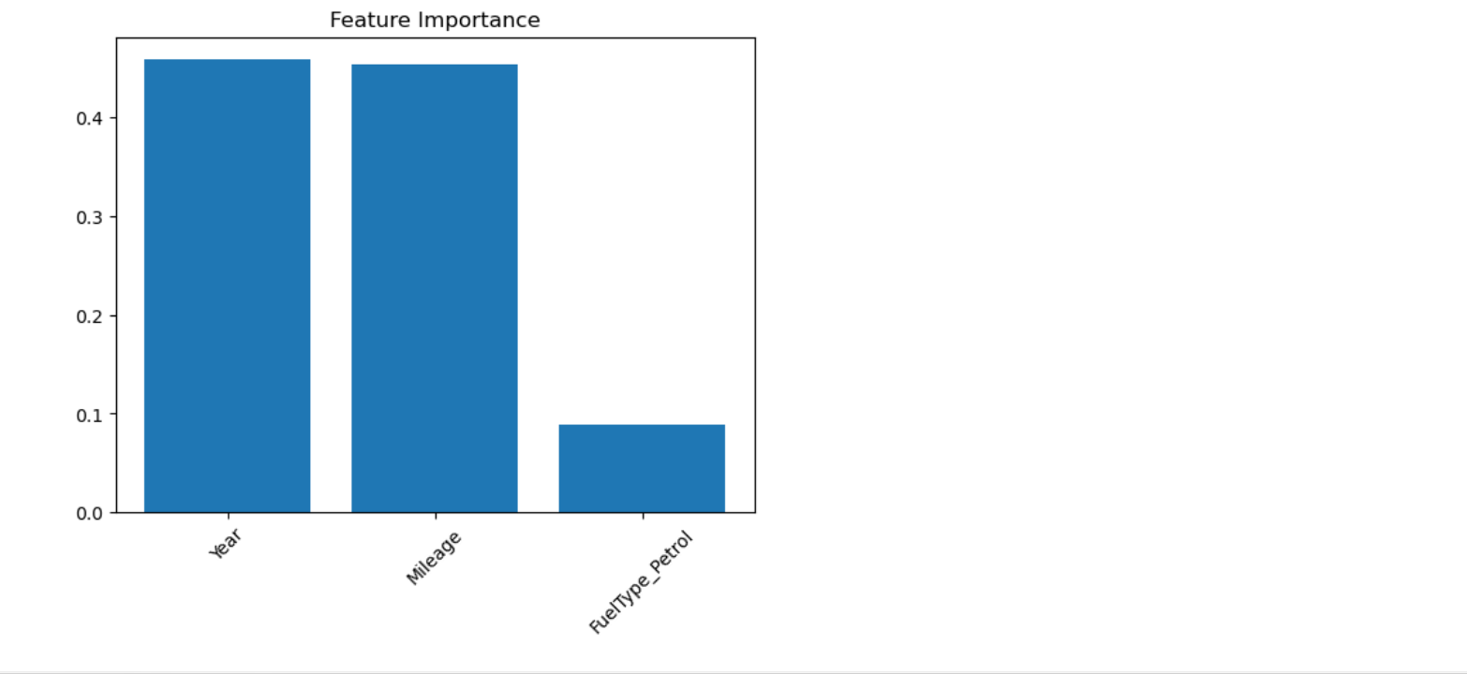
Step 7: Create Streamlit Dashboard
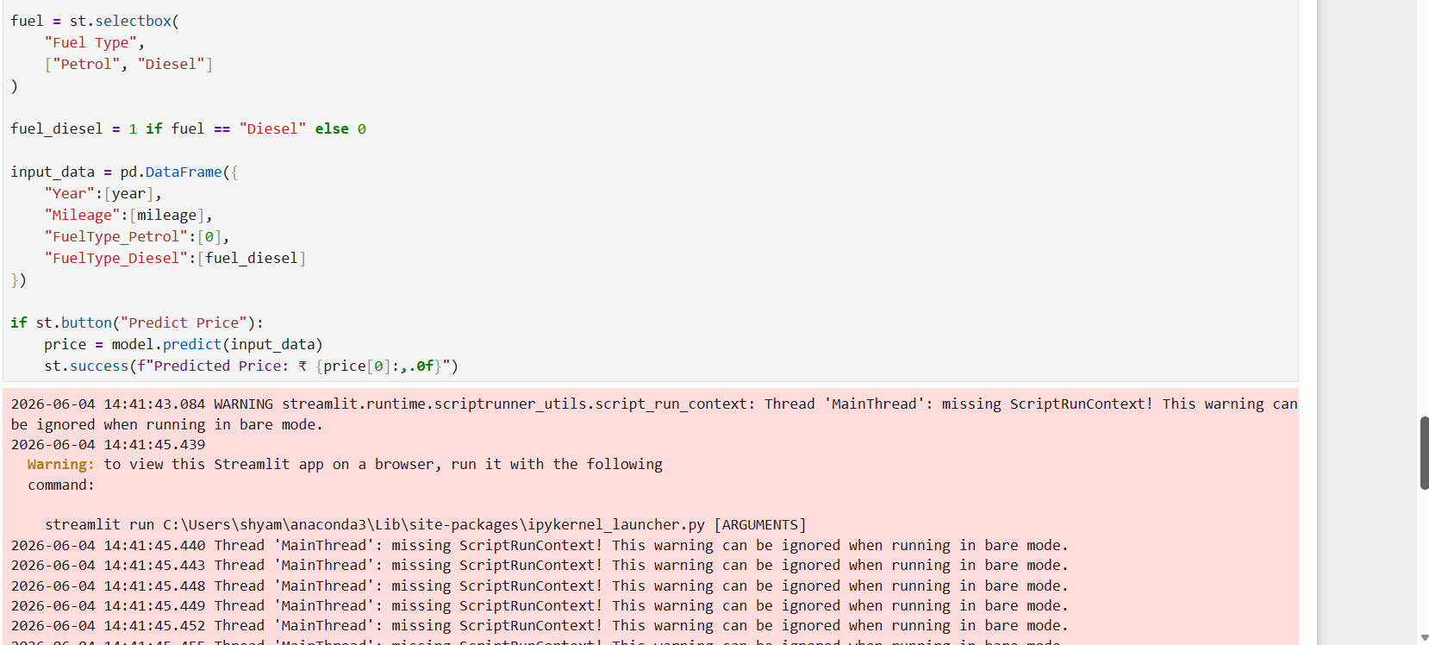

Step 8: Add Chart in Dashboard
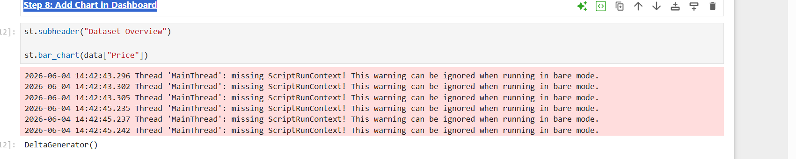
Step 9: Run Dashboard
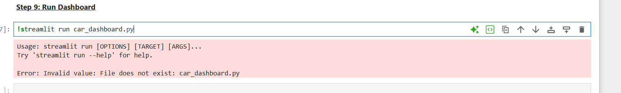
GithubLinK: https://github.com/shyamalagurugari/Car-Price-Prediction-Dashboard
Create Repositories:
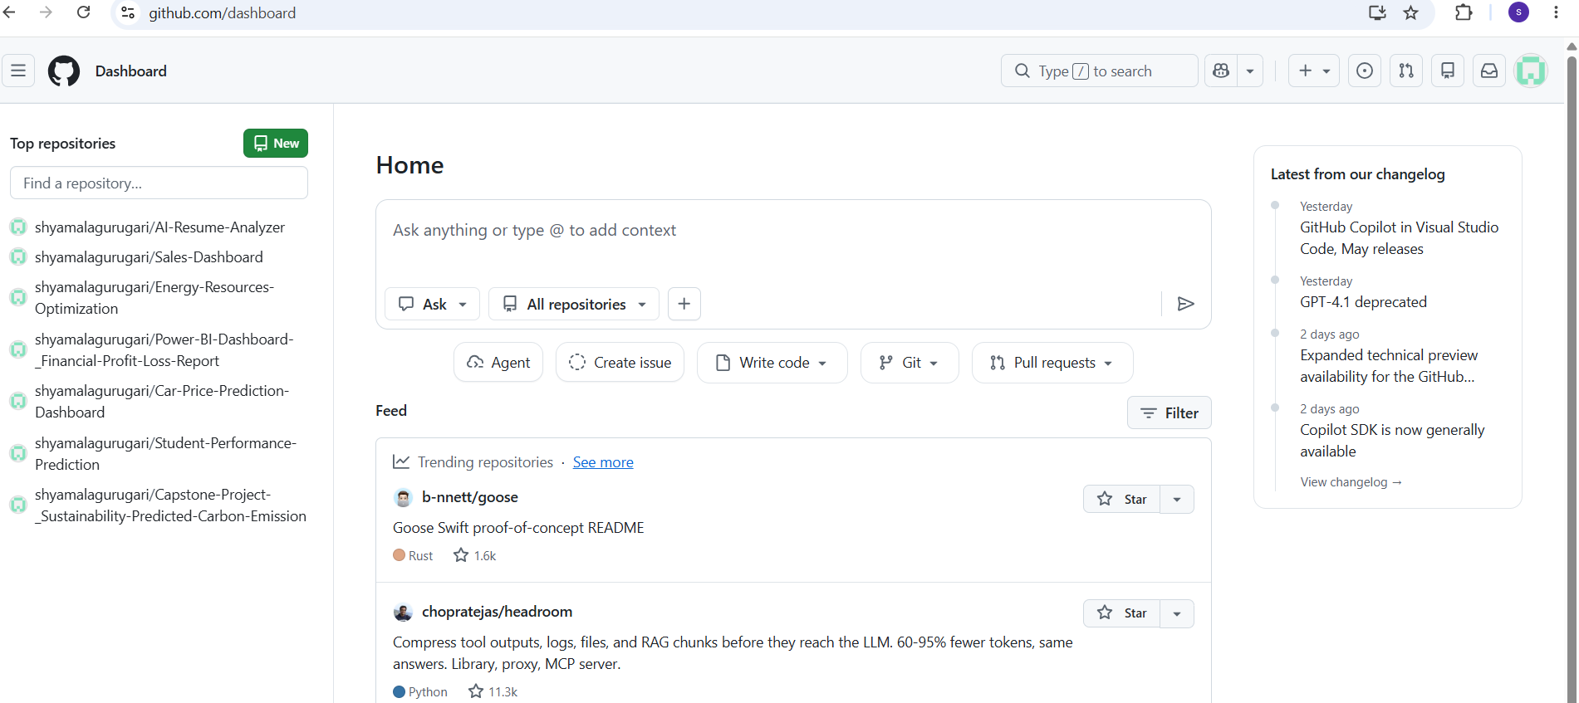
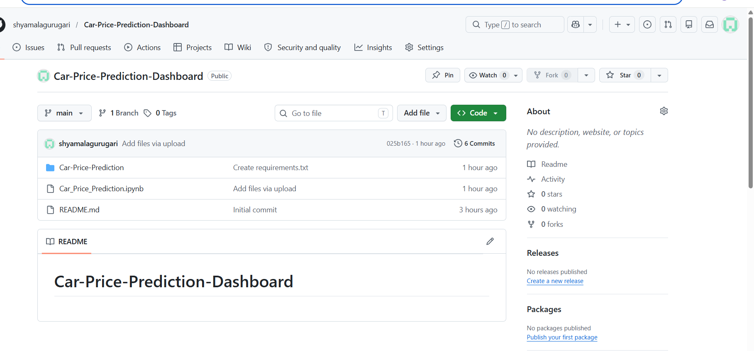
Result
The system successfully predicts used car prices based on user input and displays results in a web dashboard.
Conclusion
This project demonstrates:
- Machine learning regression modeling
- Data preprocessing and feature engineering
- Feature importance visualization
- Interactive web app development using Streamlit

